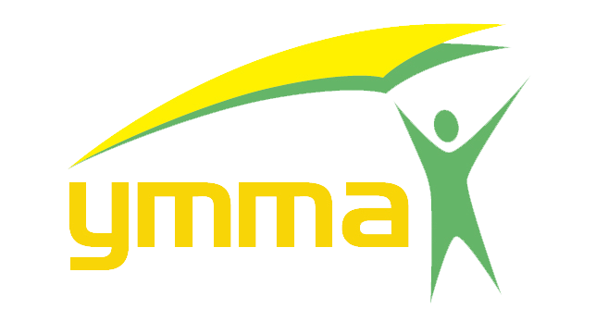
Mansmith Young Market Masters Awards
www.youngmarketmasters.com

An advocacy project organized and presented by:

I would like to nominate the following for the categories cited below:
ACCOUNT MANAGEMENT ENTREPRENEURIAL MARKETING
ADVOCACY MARKETING MARKETING MANAGEMENT
BRAND MANAGEMENT PROMOTIONAL MARKETING
BUSINESS DEVELOPMENT RETAIL MARKETING
CATEGORY MANAGEMENT SALES MANAGEMENT
CUSTOMER DEVELOPMENT TECHNOLOGY & INNOVATION
DIGITAL BUSINESS BUILDING TECHNOLOGY MARKETING
EVENTS MARKETING TRADE MANAGEMENT
OTHERS (PLS. SPECIFY)

Category
Name of Nominee
Position
Company
Email address
Mobile Number

Nominee/s must have been with the same company for at least 2 years and have done innovative marketing with outstanding results.

Nominator’s Name:
Position:
Company:
Email add:
Mobile Number:

Please email to info@youngmarketmasters.com / info@mansmith.net.

